Spring MVC HelloWorld Using Maven in Eclipse

Java developers often rely on examples to learn Spring framework. Simple examples are often a key learning resource. There are many Spring MVC HelloWorld applications. However, most of them are outdated (do not integrate Maven, use old version of Spring, etc) or not complete (missing key steps or file hierarchy view). Therefore can not lead to a perfectly working Hello World. In this article, I will show steps for creating a Spring MVC HelloWorld application using Maven in Eclipse. All files's content and locations are illustrated.
Prerequisite
- Windows 7, Java 7, Eclipse Kepler Java EE
- Tomcat 7 (How to install Tomcat 7 on Eclipse)
Step 1: Create a Maven Project
Create a Maven project by following the following steps:
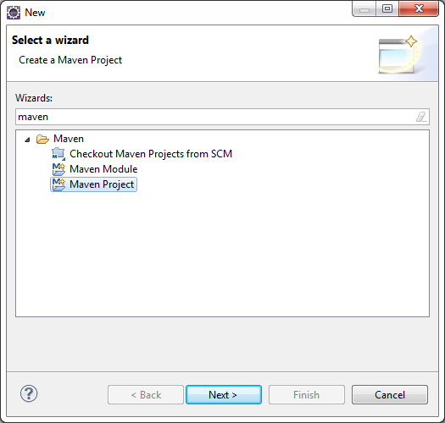
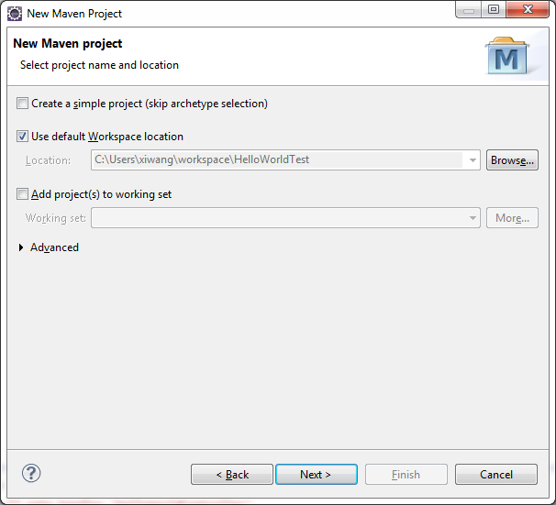
Select "webapp".
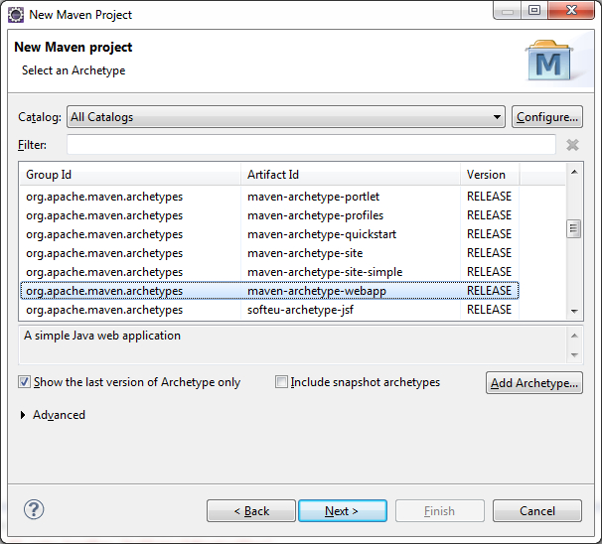
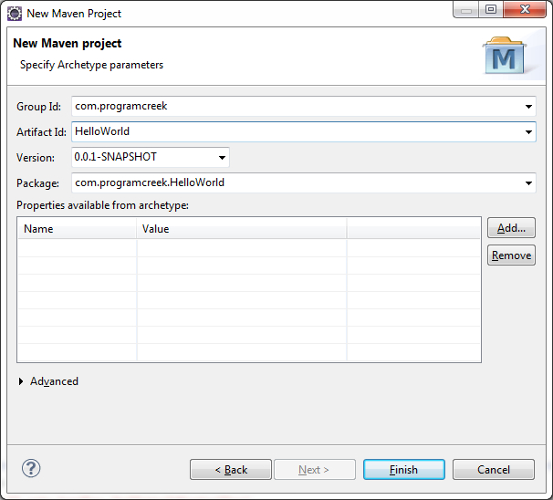
GroupId identifies the project uniquely across all projects, so we need to enforce a naming schema. ArtifactId is the name of the jar without version. For more information about each field, check out the official page about maven naming convention. (You can do this later. It makes more sense, when you complete the project first.)
After the Maven project is created, the project in the Navigator view should look like the following:
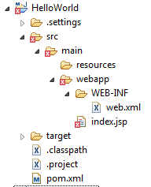
As shown above, there is an error marked with red. If you open index.jsp file, you can see the error message:
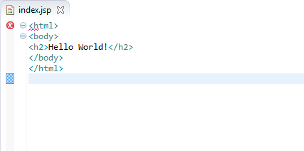
The superclass "javax.servlet.http.HttpServlet" was not found on the Java Build Path
To fix the problem, right click on project -> Properties -> Java Build Path -> Add Library...-> Server Runtime -> Apache Tomcat -> Finish.
Step 2: Configure Spring
To make a Spring web application, we need to configure several xml files. First of all, we need to add Spring dependencies. Edit the automatically generated pom.xml file to be the following:
pom.xml
<project xmlns="http://maven.apache.org/POM/4.0.0" xmlns:xsi="http://www.w3.org/2001/XMLSchema-instance"
xsi:schemaLocation="http://maven.apache.org/POM/4.0.0 http://maven.apache.org/maven-v4_0_0.xsd">
<modelVersion>4.0.0</modelVersion>
<groupId>com.programcreek</groupId>
<artifactId>HelloWorld</artifactId>
<packaging>war</packaging>
<version>0.0.1-SNAPSHOT</version>
<name>HelloWorld Maven Webapp</name>
<url>http://maven.apache.org</url>

<properties>
<spring.version>4.0.1.RELEASE</spring.version>
</properties>
<dependencies>
<dependency>
<groupId>junit</groupId>
<artifactId>junit</artifactId>
<version>3.8.1</version>
<scope>test</scope>
</dependency>
<!-- Spring dependencies -->
<dependency>
<groupId>org.springframework</groupId>
<artifactId>spring-core</artifactId>
<version>${spring.version}</version>
</dependency>

<dependency>
<groupId>org.springframework</groupId>
<artifactId>spring-web</artifactId>
<version>${spring.version}</version>
</dependency>

<dependency>
<groupId>org.springframework</groupId>
<artifactId>spring-webmvc</artifactId>
<version>${spring.version}</version>
</dependency>

</dependencies>

<build>
<finalName>HelloWorld</finalName>
</build>
</project>
Edit the default web.xml.
<?xml version="1.0" encoding="UTF-8"?>
<web-app xmlns:xsi="http://www.w3.org/2001/XMLSchema-instance" xmlns="http://java.sun.com/xml/ns/javaee" xsi:schemaLocation="http://java.sun.com/xml/ns/javaee http://java.sun.com/xml/ns/javaee/web-app_3_0.xsd" id="WebApp_ID" version="3.0">

<display-name>Archetype Created Web Application</display-name>

<servlet>
<servlet-name>dispatcher</servlet-name>
<servlet-class>
org.springframework.web.servlet.DispatcherServlet
</servlet-class>
<load-on-startup>1</load-on-startup>
</servlet>

<servlet-mapping>
<servlet-name>dispatcher</servlet-name>
<url-pattern>/</url-pattern>
</servlet-mapping>

<context-param>
<param-name>contextConfigLocation</param-name>
<param-value>/WEB-INF/dispatcher-servlet.xml</param-value>
</context-param>

<listener>
<listener-class>
org.springframework.web.context.ContextLoaderListener
</listener-class>
</listener>
</web-app>
Create an xml file "dispatcher-servlet.xml" under the same directory of web.xml.
<beans xmlns="http://www.springframework.org/schema/beans"
xmlns:context="http://www.springframework.org/schema/context"
xmlns:xsi="http://www.w3.org/2001/XMLSchema-instance"
xsi:schemaLocation="
http://www.springframework.org/schema/beans
http://www.springframework.org/schema/beans/spring-beans-3.0.xsd
http://www.springframework.org/schema/context
http://www.springframework.org/schema/context/spring-context-3.0.xsd">

<context:component-scan base-package="com.programcreek.helloworld.controller" />

<bean
class="org.springframework.web.servlet.view.InternalResourceViewResolver">
<property name="prefix">
<value>/WEB-INF/views/</value>
</property>
<property name="suffix">
<value>.jsp</value>
</property>
</bean>
</beans>
In the above xml file, base-package specifies the package of the controllers. prefix specifies the directory of views, and it is set to be /WEB-INF/views/, which means views directory should be created under WEB-INF. suffix specifies the file extension of views. For example, given a view "helloworld", the view will be located as /WEB-INF/views/helloworld.jsp. You can figure this out later in Step 3.
Step 3: Create Spring Controller and View
Create the HelloWorldController under src/main/java/ directory.
HelloWorldController.java
package com.programcreek.helloworld.controller;

import org.springframework.stereotype.Controller;
import org.springframework.ui.Model;
import org.springframework.web.bind.annotation.RequestMapping;
import org.springframework.web.bind.annotation.RequestParam;
import org.springframework.web.servlet.ModelAndView;

@Controller
public class HelloWorldController {
String message = "Welcome to Spring MVC!";

@RequestMapping("/hello")
public ModelAndView showMessage(
@RequestParam(value = "name", required = false, defaultValue = "World") String name) {
System.out.println("in controller");

ModelAndView mv = new ModelAndView("helloworld");
mv.addObject("message", message);
mv.addObject("name", name);
return mv;
}
}
In the code above, @RequestMapping annotation maps web requests onto specific handler classes and/or handler methods, in this case, showMessage(). It provides a consistent style between Servlet and Portlet environments, with the semantics adapting to the concrete environment.
RequestParam indicates that a method parameter should be bound to a web request parameter. In this case, we also make it not required and give it a default value.
new ModelAndView("helloworld") determines that helloworld is the target view.
index.jsp
<%@ page language="java" contentType="text/html; charset=ISO-8859-1"

pageEncoding="ISO-8859-1"%>
<!DOCTYPE html PUBLIC "-//W3C//DTD HTML 4.01 Transitional//EN" "http://www.w3.org/TR/html4/loose.dtd">
<html>
<head>
<meta http-equiv="Content-Type" content="text/html; charset=ISO-8859-1">
<title>Spring 4 MVC - HelloWorld Index Page</title>
</head>
<body>

<center>
<h2>Hello World</h2>
<h3>
<a href="hello?name=Eric">Click Here</a>
</h3>
</center>
</body>
</html>
Create the helloworld.jsp file under /WEB-INF/views/ directory.
helloworld.jsp
<%@ page language="java" contentType="text/html; charset=ISO-8859-1" pageEncoding="ISO-8859-1"%>
<!DOCTYPE html PUBLIC "-//W3C//DTD HTML 4.01 Transitional//EN" "http://www.w3.org/TR/html4/loose.dtd">
<html>
<head>
<meta http-equiv="Content-Type" content="text/html; charset=ISO-8859-1">
<title>Spring 4 MVC -HelloWorld</title>
</head>
<body>
<center>
<h2>Hello World</h2>
<h2>
${message} ${name}
</h2>
</center>
</body>
</html>
${variable} will be converted to the value of the variable.
Final Navigator view of the project:
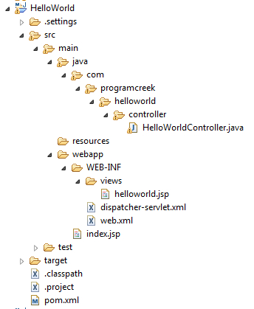
Step 4: Run on Server
Right click the project and select Run As --> Run on Server.
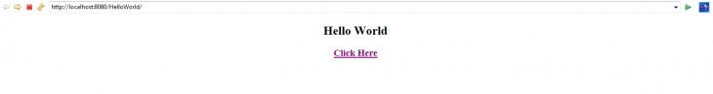
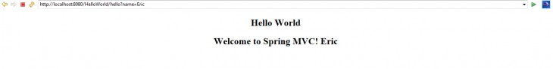

Spring MVC – Setter Dependency Injection

In previous tutorial, we have seen how to create a simple Hello World Spring application using Maven under Eclipse. In the Hello World application, we used annotation. In this tutorial, I will show how to use xml configuration and setter dependency injection. Instead of showing a message in the final view, this time it shows a list of employees.

Step 1: Create Bean and Manager Classes
Employee.java
package com.programcreek.helloworld.model;

public class Employee {
private String id;
private String lastName;
private String firstName;

public Employee(String id, String lastName, String firstName) {
this.id = id;
this.lastName = lastName;
this.firstName = firstName;
}

public String getId() {
return id;
}
public void setId(String id) {
this.id = id;
}
public String getLastName() {
return lastName;
}
public void setLastName(String lastName) {
this.lastName = lastName;
}
public String getFirstName() {
return firstName;
}
public void setFirstName(String firstName) {
this.firstName = firstName;
}
}
EmployeeManager.java
package com.programcreek.helloworld.service;

import java.util.ArrayList;
import java.util.List;
import com.programcreek.helloworld.model.Employee;

public class EmployeeManager {
private static List<Employee> employeeList;

public EmployeeManager(){
employeeList = new ArrayList<Employee>();
employeeList.add(new Employee("1", "Mike", "Smith"));
employeeList.add(new Employee("2", "John", "Taylor"));
employeeList.add(new Employee("3", "Dave", "Wilson"));
}

public List<Employee> getEmployeeList(){
return employeeList;
}
}
Step 2: Create Controller
EmployeeController.java
package com.programcreek.helloworld.controller;

import javax.servlet.http.HttpServletRequest;
import javax.servlet.http.HttpServletResponse;
import org.springframework.web.servlet.ModelAndView;
import org.springframework.web.servlet.mvc.Controller;
import com.programcreek.helloworld.service.EmployeeManager;

public class EmployeeController implements Controller {
private EmployeeManager employeeManager;

public EmployeeManager getEmployeeManager() {
return employeeManager;
}

public void setEmployeeManager(EmployeeManager employeeManager) {
this.employeeManager = employeeManager;
}

public ModelAndView handleRequest(HttpServletRequest arg0,
HttpServletResponse arg1) throws Exception {
System.out.println("in EmployeeController");
ModelAndView mv = new ModelAndView("employeeList");
mv.addObject("employeeList", this.employeeManager.getEmployeeList());
return mv;
}
}
Step 3: Create View
Create another view file - employeeList.jsp under the views directory.
<%@ taglib prefix="c" uri="http://java.sun.com/jsp/jstl/core"%>

<%@ page language="java" contentType="text/html; charset=ISO-8859-1" pageEncoding="ISO-8859-1"%>
<!DOCTYPE html PUBLIC "-//W3C//DTD HTML 4.01 Transitional//EN" "http://www.w3.org/TR/html4/loose.dtd">
<html>
<head>
<meta http-equiv="Content-Type" content="text/html; charset=ISO-8859-1">
<title>Spring 4 MVC - Employee List</title>
</head>
<body>
<center>

<c:forEach items="${employeeList}" var="employee">
${employee.id}: ${employee.lastName}, ${employee.firstName}<br>
</c:forEach>

</center>
</body>
</html>
c: is from jstl. So I add <%@ taglib prefix="c" uri="http://java.sun.com/jsp/jstl/core"%>. This will give a warning message "Can not find the tag library descriptor for "http://java.sun.com/jsp/jstl/core". ". To fix the problem, open pom.xml file, and add the dependency by using the following code:
<dependency>
<groupId>jstl</groupId>
<artifactId>jstl</artifactId>
<version>1.2</version>
</dependency>
Change the index.jsp file to the following:
<%@ page language="java" contentType="text/html; charset=ISO-8859-1"

pageEncoding="ISO-8859-1"%>
<!DOCTYPE html PUBLIC "-//W3C//DTD HTML 4.01 Transitional//EN" "http://www.w3.org/TR/html4/loose.dtd">
<html>
<head>
<meta http-equiv="Content-Type" content="text/html; charset=ISO-8859-1">
<title>Spring 4 MVC - HelloWorld Index Page</title>
</head>
<body>
<center>
<h3>
<a href="hello">Hello World</a>
</h3>

<h3>
<a href="employee">Employee List</a>
</h3>

</center>
</body>
</html>
Step 4: Configure XML File
Now we need to configure the dispatcher-servlet.xml file. After changing, it should looks like the following:
<beans xmlns="http://www.springframework.org/schema/beans"
xmlns:context="http://www.springframework.org/schema/context"
xmlns:xsi="http://www.w3.org/2001/XMLSchema-instance"
xsi:schemaLocation="
http://www.springframework.org/schema/beans
http://www.springframework.org/schema/beans/spring-beans-3.0.xsd
http://www.springframework.org/schema/context
http://www.springframework.org/schema/context/spring-context-3.0.xsd">

<context:component-scan base-package="com.programcreek.helloworld.controller" />

<bean id="employeeManager" class="com.programcreek.helloworld.service.EmployeeManager" />

<bean name="/employee" class="com.programcreek.helloworld.controller.EmployeeController">
<property name="employeeManager" ref="employeeManager"/>
</bean>

<bean
class="org.springframework.web.servlet.view.InternalResourceViewResolver">
<property name="prefix">
<value>/WEB-INF/views/</value>
</property>
<property name="suffix">
<value>.jsp</value>
</property>
</bean>
</beans>
Final Result
Final Navigator view looks like the following:
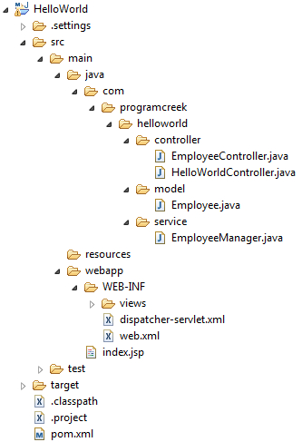
Running the project, we will get the views.
Index Page
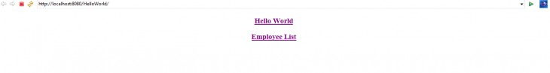
Employee List Page
